**Start-all.sh will start all the deamons.**

**Example: namenode , secondary namenode, datanode, resource manager etc..,**

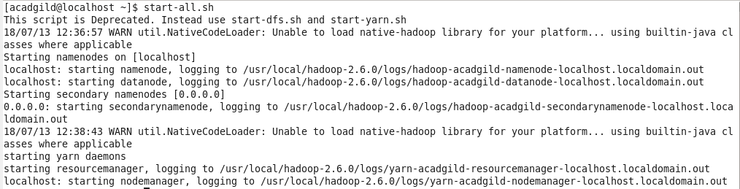

Jps command will show the deamons which are active.

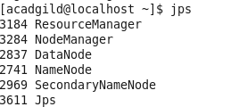

Pwd will display the present working directory



**Stop-all.sh will stop all the running deamons.**

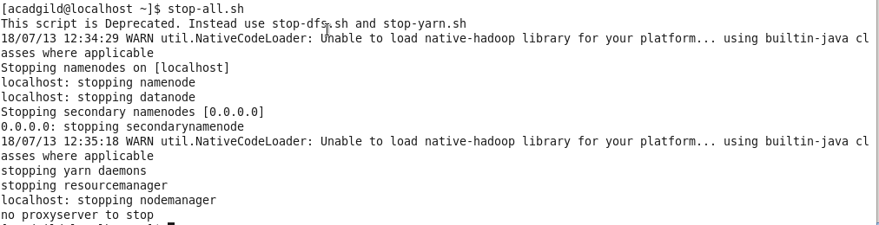

File will be created in the local directory using **nano**



Type the content of file. PRESS ctrl +x and then Y to save.

It will be viewed by using cat.



**It will be inserted into hadoop using put command.**



Type hadoop fs – ls / to view the file

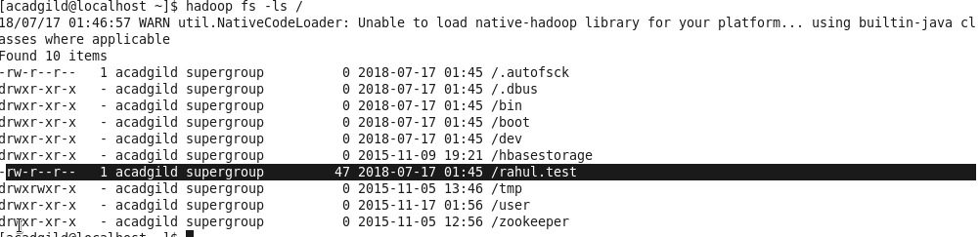

To view

